LAB REPORT实验报告
Lab Title | Dynamic Linked List |  |  |  | Lab No. | 09
Stud. Name | Jiang Yunxiang | Major | CST |  | Class
Student ID | 2022102330 |  | Date | 4/21
Lab description/objectives:
Add two functions printFor(), printRev() to Program 13.7 pgm13-7.c that print elements of the linked list in forward, and reverse order using recursion.

Source code:
（Paste the source code here）
#include <stdio.h>
#include <stdlib.h>
#include <string.h>
#define MAXCHARS 30
#define DEBUG 0

/* here is the declaration of a linked list structure */
struct NameRec {
char name[MAXCHARS];
struct NameRec* nextAddr;
};

/* here is the definition of the first structure pointer */
struct NameRec* firstRec;

int main()
{
void printFor();
void printRev();
void readInsert(); /* function prototypes */
void display();

firstRec = NULL; /* initialize list pointer */
readInsert();
printf("The print elements of the linked list in forward:\n");
printFor(firstRec);
printf("The print elements of the linked list in reverse:\n");
printRev(firstRec);

return 0;
}

/* get a name and insert it into the linked list */
void readInsert()
{
char name[MAXCHARS];
void insert(char*);

printf("\nEnter as many names as you wish, one per line");
printf("\nTo stop entering names, enter a single x\n");
while (1) {
printf("Enter a name: ");
gets(name);
if (strcmp(name, "x") == 0)
break;
insert(name);
}
}

void insert(char* name)
{
struct NameRec* linearLocate(char*); /* function prototype */
struct NameRec* newaddr, * here; /* pointers to structure */
/* of type NameRec */

newaddr = (struct NameRec*)malloc(sizeof(struct NameRec));
if (newaddr == (struct NameRec*)NULL) /* check the address */
{
printf("\nCould not allocate the requested space\n");
exit(1);
}

/* locate where the new structure should be placed and */
/* update all pointer members */
if (firstRec == NULL) /* no list currently exists */
{
newaddr->nextAddr = NULL;
firstRec = newaddr;
}
else if (strcmp(name, firstRec->name) < 0) /* a new first structure */
{
newaddr->nextAddr = firstRec;
firstRec = newaddr;
}
else /* structure is not the first structure of the list */
{
here = linearLocate(name);
newaddr->nextAddr = here->nextAddr;
here->nextAddr = newaddr;
}

strcpy(newaddr->name, name); /* store the name */
}

/* This function locates the address of where a new structure
should be inserted within an existing list.
It receives the address of a name and returns the address of a
structure of type NameRec
*/
struct NameRec* linearLocate(char* name)
{
struct NameRec* one, * two;
one = firstRec;
two = one->nextAddr;

if (two == NULL)
return (one); /* new structure goes after the existing single structure */
while (1) {
if (strcmp(name, two->name) < 0) /* if it is located within the list */
break;
else if (two->nextAddr == NULL) /* it goes after the last structure */
{
one = two;
break;
}
else /* more structures to search against */
{
one = two;
two = one->nextAddr;
}
} /* the break takes us here */

return (one);
}

/* display names from the linked list */
void display()
{
struct NameRec* contents;

contents = firstRec;
printf("\nThe names currently in the list, in alphabetical");
printf("\norder, are:\n");
while (contents != NULL) /* display till end of list */
{
printf("%s\n", contents->name);
contents = contents->nextAddr;
}
}
void printFor(struct NameRec* p)
{
if (p == NULL) {
return;
}
printf("%s\n", p->name);
printFor(p->nextAddr);
}

void printRev(struct NameRec* p)
{
if (p == NULL) {
return;
}
printRev(p->nextAddr);
printf("%s\n", p->name);
}
Program outputs:
（Paste the screenshot of program output here）
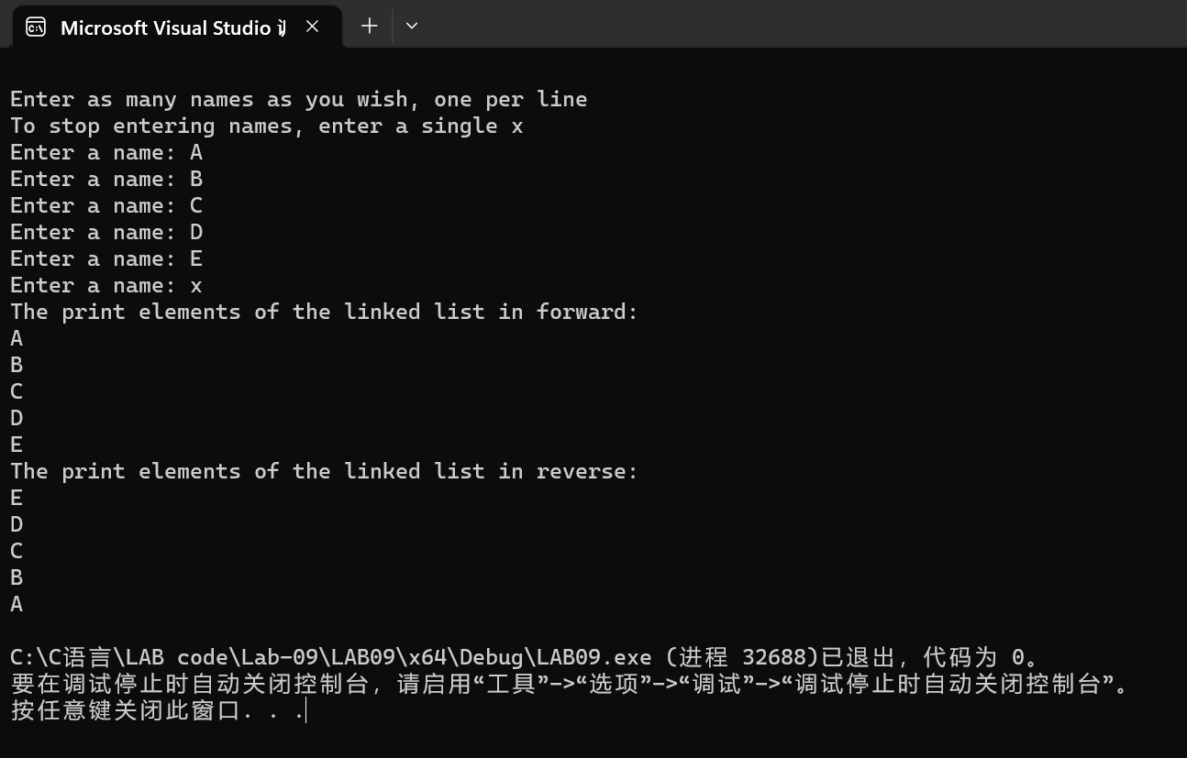
Discussion:
1．Most difficult parts
（What were the most difficult parts of your program to implement?）
Nope
2．Bugs and/or Errors
(List all the program bugs/errors you encountered and how you corrected them.)
Nope

